



Sistem Informasi Senikersku

Kelompok c09

SCHEDULE MANAGEMENT PLAN

Version <1.0>

<27/09/2021>

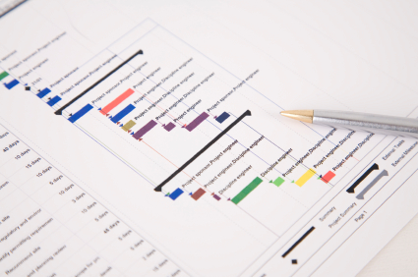

Document Control

Document Information

 | Information
Document Id | 1
Document Owner | Bontang Hebat 2021
Issue Date | 27 September 2021
Last Saved Date | 27 September 2021
File Name | SMP(1.0) – Bontang Hebat

Document History

Version | Issue Date | Changes
[1.0] | 27 - 09 - 2021

Document Approvals

Role | Name© | Signature | Date
Project Sponsor | Bambang Suardi
Project Review Group | Sarwosri, S.Kom. M.T
Project Manager© | Aji Rindra Fakhrezi Putra Faisal
Quality Manager | Christian Bennett Robin
Procurement Manager | Gerald Elroy Van Ryan
Communications Manager | Gerald Elroy Van Ryan
Project Office Manager | Sarwosri, S.Kom. M.T

Table of Contents
<Project Name> i
<Project Reference> i
SCHEDULE MANAGEMENT PLAN i
Version <1.0> i
<dd/mm/yyyy> i
Document Control i
Document Information i
Document History i
Document Approvals i
Template Guide 1
SCHEDULE METHOD AND TECHNIQUE 2
SCHEDULING SOFTWARE 2
ESTIMATE TOLERANCES 2
Scheduling measurements 2
related organisational procedures 3
SCHEDULE MAINTENANCE 3
SCHEDULE TOLERANCES 3
MEASURING PROGRESS 3
SCHEDULING AND REPORTING FORMAT 3
DOWNLOAD MORE PROJECT TEMPLATES 5

Template Guide
How to use this template
This is a guide to the common sections included in a Schedule Management Plan. Sections may be added, removed or amended to suit your project. Example tables have been added (where relevant) these are just a suggestion, you may decide to format these sections differently.
Text in Blue italics is designed to assist you in completing the template. Delete this text before sharing the final document.

SCHEDULE METHOD AND TECHNIQUE
Jadwal dari sebuah proyek adalah sebuah pedoman tentang bagaimana dan berapa lama proyek tersebut akan dijalankan. Melakukan penjadwalan merupakan hal yang penting dalam proyek Sistem Informasi Campuspedia Academy. Dokumen Manajemen Waktu memaparkan target-target yang akan dicapai, berupa artefak pada tiap milestones, ketika menjalankan proyek sesuai dengan timeline yang telah dibuat. Selain itu, perancangan jadwal dalam dokumen ini akan mengontrol dan mengelola jadwal-jadwal dari proyek.
Metode yang digunakan dalam melakukan penjadwalan atau pembuatan timeline untuk proyek Sistem Informasi Senikersku adalah Critical Path Method (CPM) dan juga Gantt Chart. Critical Path Method digunakan untuk menentukan berapa lama dari waktu yang akan dihabiskan dalam pengerjaan elemen pekerjaan. CPM ini divisualisasikan dengan menggunakan Precedence Diagram. Gantt Chart juga digunakan sebagai monitor lama dari pekerjaan dalam proyek agar dapat berjalan sesuai dengan ketentuan yang ditetapkan.
CPM dan Gantt Chart

SCHEDULING SOFTWARE
<Note the scheduling software that will be used during the project. This may well be already decided by a wider organizational standard. You could include any requirements around additional licenses and refer to any default settings that will be used. For example, pre-agreed non-working days so that work is not scheduled over holidays like Christmas.>
Persyaratan terkait jadwal misal minggu dan tgl merah libur.

ESTIMATE TOLERANCES
<Document the procedure that you will use when the project or a work package is forecast to exceed the schedule or cost tolerances.
See an example of cost tolerances.>
Jika ada keterlambatan, brp hari toleransi penambahannya (bisa dibuat per parent activity yaitu bagian bar warna hitam atau detil per activityyg berpotensi molor)

Scheduling measurements
<Note the unit of measurement which will be used for each resource type on your project. For example, staff hours or days, for time durations or meters, tons, kilometers for quantity measures.
You could use a table like the one shown below.>
Item | Unit of measurement
Human resources effort | Days and Hours. Min 4 hours and max 10 days. Greater duration requires further decomposition to ensure scheduling accuracy.
Human resources cost | Day rate x effort. Minimum ½ day.
Concrete | Cubic meters + 0% reserve
Sand | As for Concrete
Container | Number of items at x m2.

Get a Resource Plan template.

related organisational procedures
<Include relevant links to organizational procedures. For example, process documentation for the control and updating of the schedule, or pre-agreed settings in the scheduling tool like nonworking time or the duration of the working day.>
<<optional>>

SCHEDULE MAINTENANCE
<Explain how the schedule will be maintained. For example, how it will be updated (perhaps via project team calls), version numbering and control, and who will own the master plan. Also describe how the progress of tasks in the schedule will be shown. For example, when and how schedule baselines will be created.>
Silahkan diisi

SCHEDULE TOLERANCES
<Document the amount of deviation from agreed schedule tolerances that can happen before corrective action needs to be taken.
Sometimes known as variance thresholds, schedule tolerances are percentage deviations from the schedule’s baseline. For example, it might be permissible for scheduled activities to be delayed by up to 5% but no further. Another example could be that it is acceptable to be behind schedule by up to one week, but any further delay would trigger a project board escalation.>
What is Project Tolerance?

MEASURING PROGRESS
<Document the procedure for saving the baseline (the dates against which progress will be measured). Note how and when actual start and finish dates will be collected, and for tasks in progress how the amount of work completed, and the time needed to finish the task is measured.
Include what tools or techniques will be used to establish the progress of the work against the schedule overall. For example, earned value management techniques, schedule variance, and schedule performance index.>
Catat tgl aktual mulai dan aktual selesai

SCHEDULING AND REPORTING FORMAT
<Make a note of the formats that you plan to use to for scheduling and reporting. For example, you might use a Gantt Chart and Tracking Gantt for day to day management of the project combined with resource to do lists. For reporting purposes, you might use a timeline format. This could be created separately in PowerPoint of use Microsoft Project’s inbuilt timeline function.>
Example formats
Timeline created with Microsoft Project
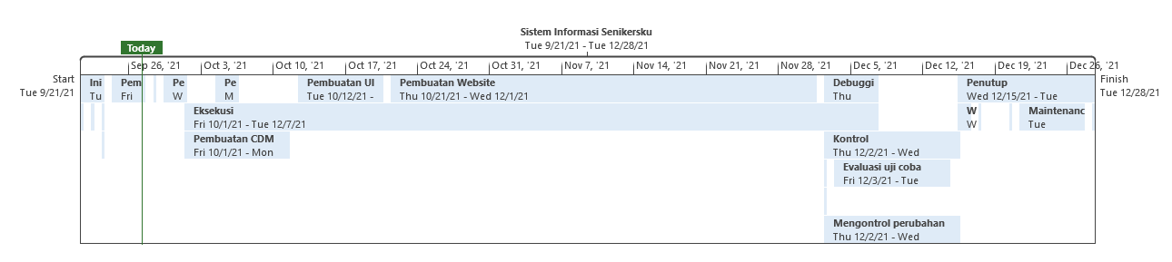
Timeline built in PowerPoint
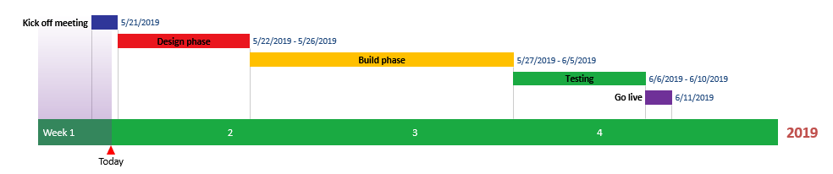
See also:
How to make a timeline in PowerPoint
How to use Microsoft project to create a timeline

Wajib Pakai Ms Project, ikuti tutorial di link
https://www.stakeholdermap.com/project-templates/schedule-management-plan-template.html

